Module 01 Lab 02 Laptop Pricing Screenshot Evidence and Discussion
Reference label for this notebook: Lab2 (each heading below is numbered Lab2_1, Lab2_2 and so on).
This document gathers the screenshots for Module 01 Lab 02, Importing Data Sets for laptop pricing, and gives each one a heading that follows the six tasks of the notebook in order. The lab loads laptop_pricing_dataset_base.csv, a headerless file with 238 rows and 12 attributes, adds the column names, replaces the question mark markers and runs the descriptive checks. The file name of every screenshot is printed below the image.

Lab2_1. Section 1 Downloading the laptop dataset
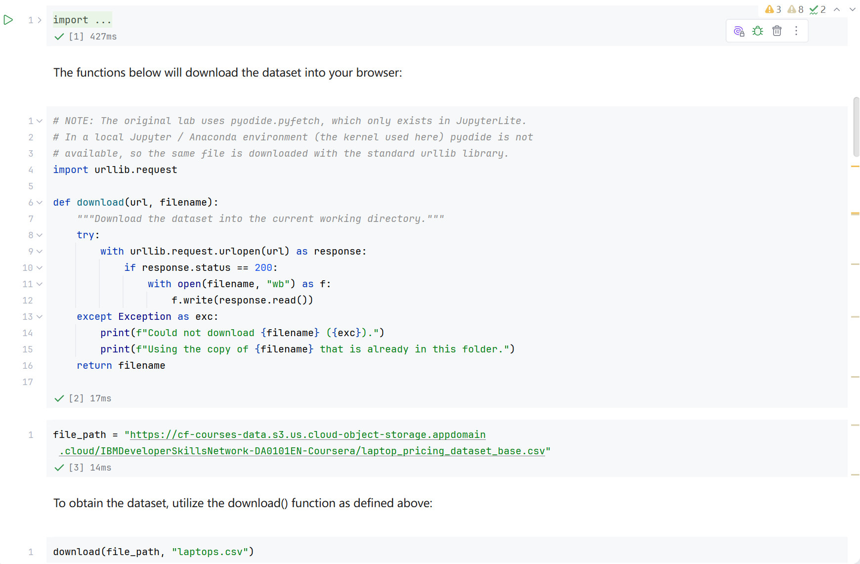
Screenshot file: 01_download_function_urllib.png
(image width 16.4 cm, scale to fit)
The download function fetches laptop_pricing_dataset_base.csv with urllib and stores it as laptops.csv in the working directory so the notebook can read it locally, with a fallback to the existing copy if the download fails.

Lab2_2. Section 1 Reading the CSV straight from its URL
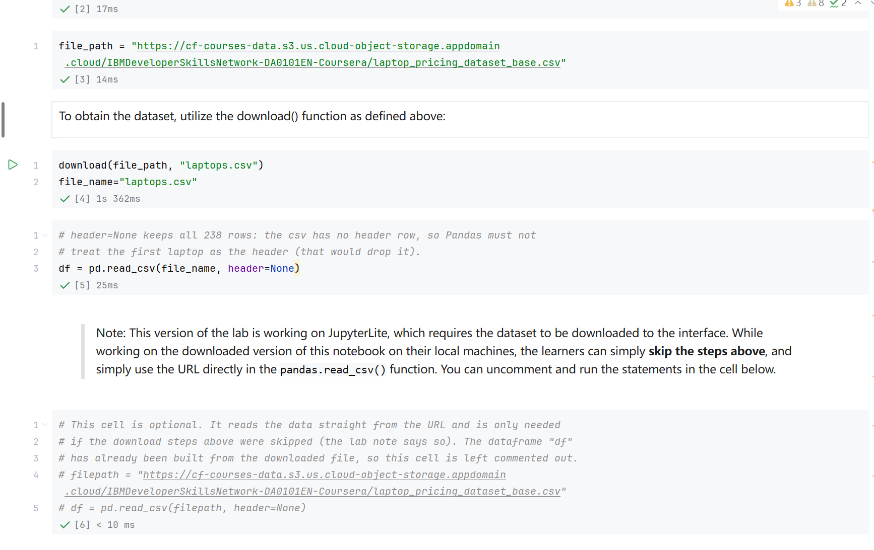
Screenshot file: 02_read_csv_url_option_commented.png
(image width 16.4 cm, scale to fit)
The optional alternative reads the same file directly from the course URL with pandas read_csv and header=None. It stays commented out because the file was already downloaded.

Lab2_3. Task 1 Loading the dataset and printing the first five rows
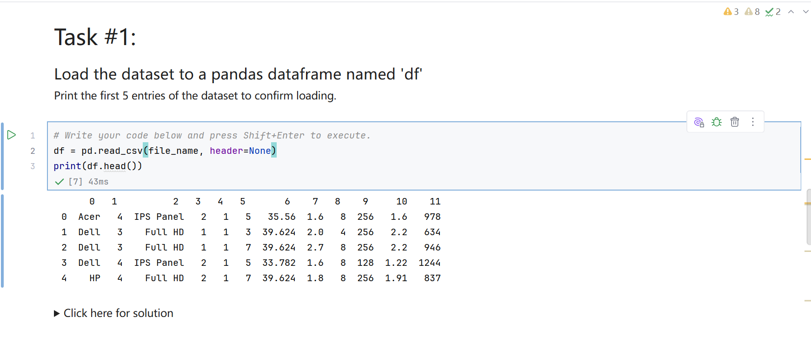
Screenshot file: 03_Task1_pd.read_csv_and_df.head.png
(image width 16.4 cm, scale to fit)
df is created with pd.read_csv on file_name using header=None because the file has no header row, and the first five entries are printed to confirm that 238 rows and 12 columns were loaded.

Lab2_4. Task 2 Adding the 12 column headers
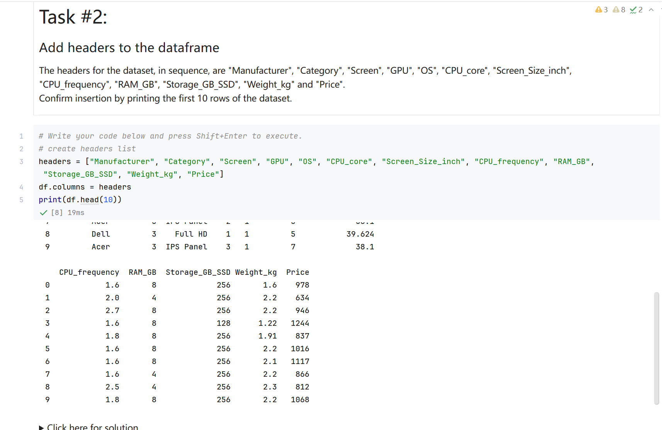
Screenshot file: 04_Task2_headers_and_df.head_10.png
(image width 16.4 cm, scale to fit)
The headers list is assigned to df.columns and df.head(10) confirms the insertion, showing Manufacturer, Category, Screen, GPU, OS, CPU core, Screen Size inch, CPU frequency, RAM GB, Storage GB SSD, Weight kg and Price.

Lab2_5. Task 3 Replacing the question marks with NaN
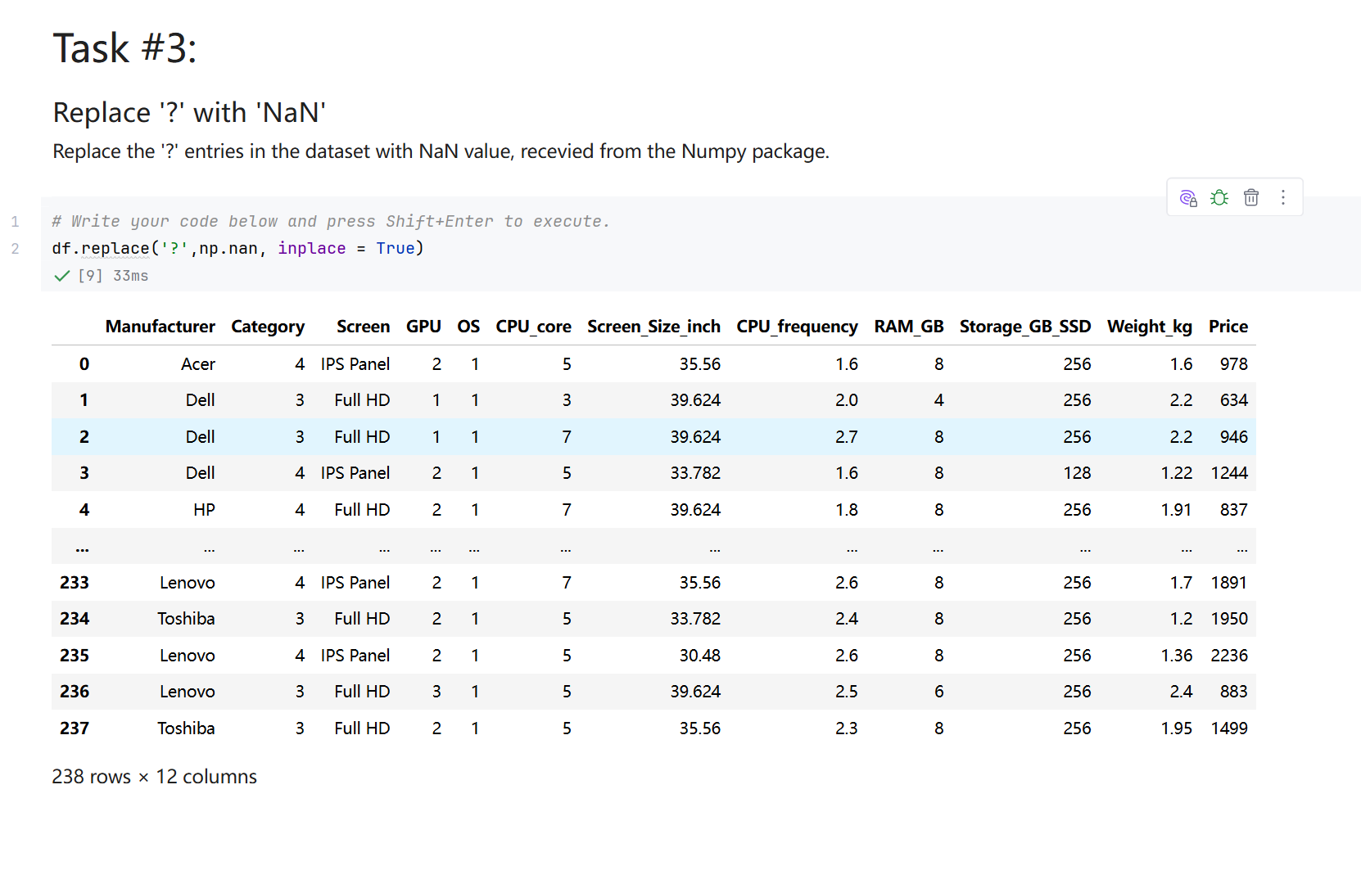
Screenshot file: 05_Task3_df.replace_with_NaN.png
(image width 16.4 cm, scale to fit)
df.replace converts the missing value markers into real missing values, the step that makes the following type checks meaningful.

Lab2_6. Task 4 Data types of the columns
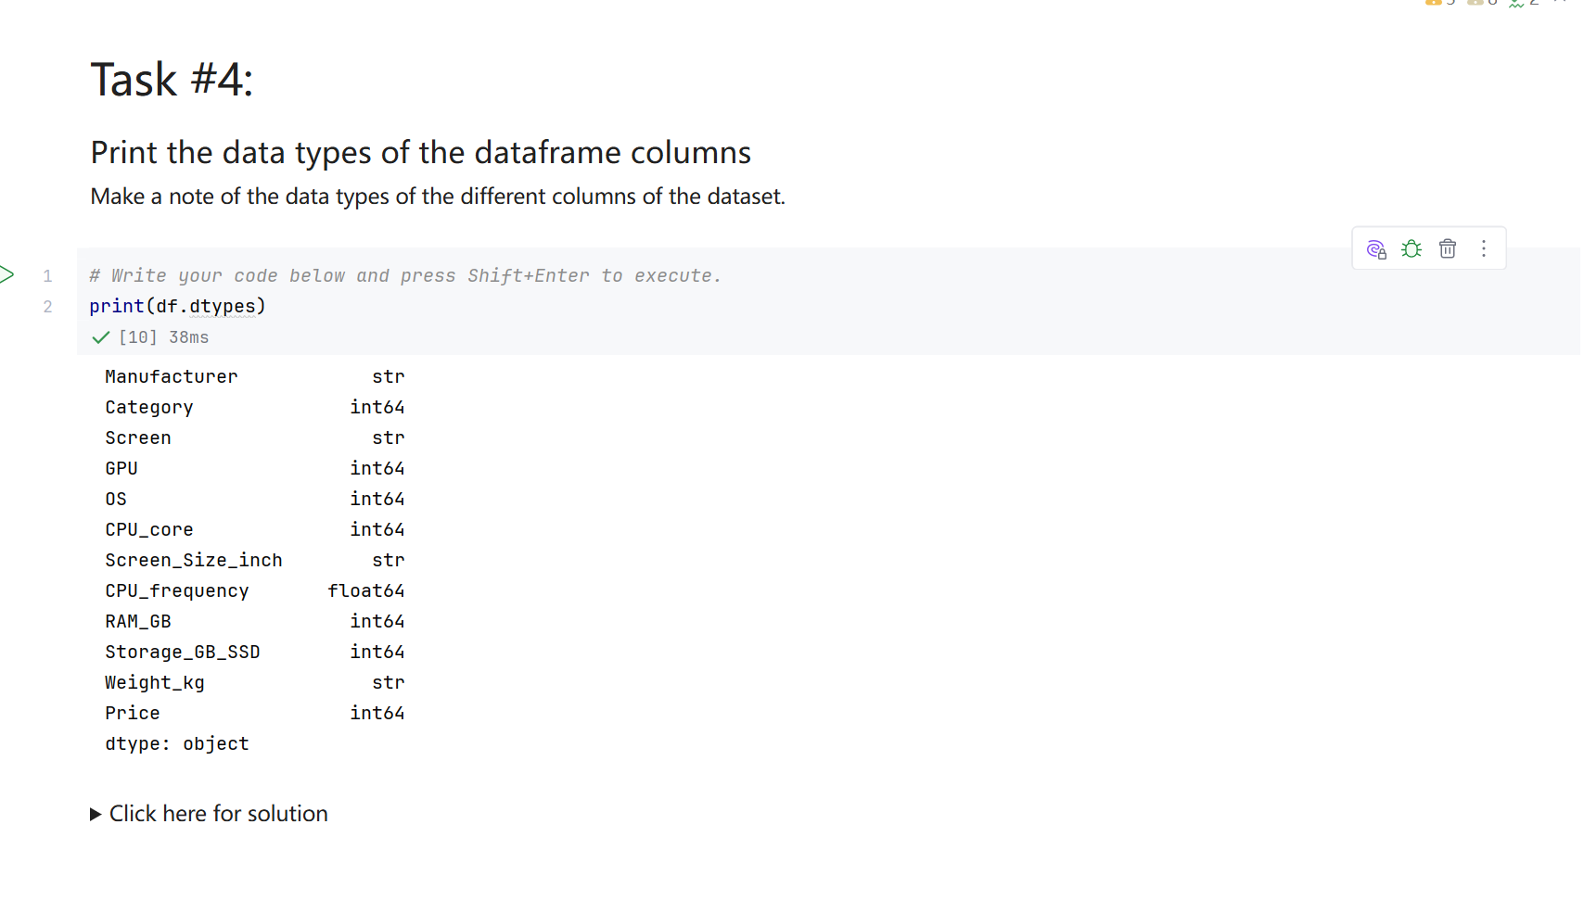
Screenshot file: 06_Task4_print_df.dtypes.png
(image width 16.4 cm, scale to fit)
print(df.dtypes) lists the type of each column. Screen Size inch and Weight kg appear as object because they now hold NaN, while the hardware attributes are integers and CPU frequency is a float.

Lab2_7. Task 5 Statistical description including the object columns
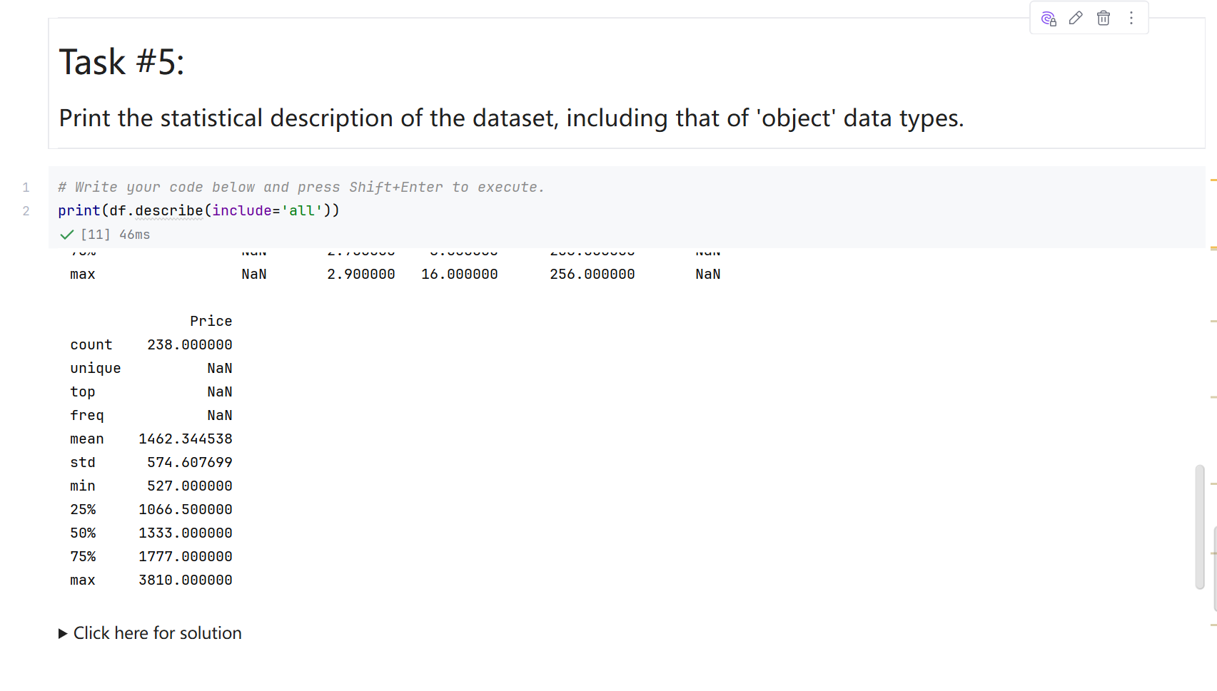
Screenshot file: 07_Task5_print_df.describe_include_all.png
(image width 16.4 cm, scale to fit)
print(df.describe(include='all')) extends the usual numeric summary with count, unique, top and frequency for the text columns, so the manufacturer and screen type distributions can be read at a glance.

Lab2_8. Task 6 Summary information of the dataset
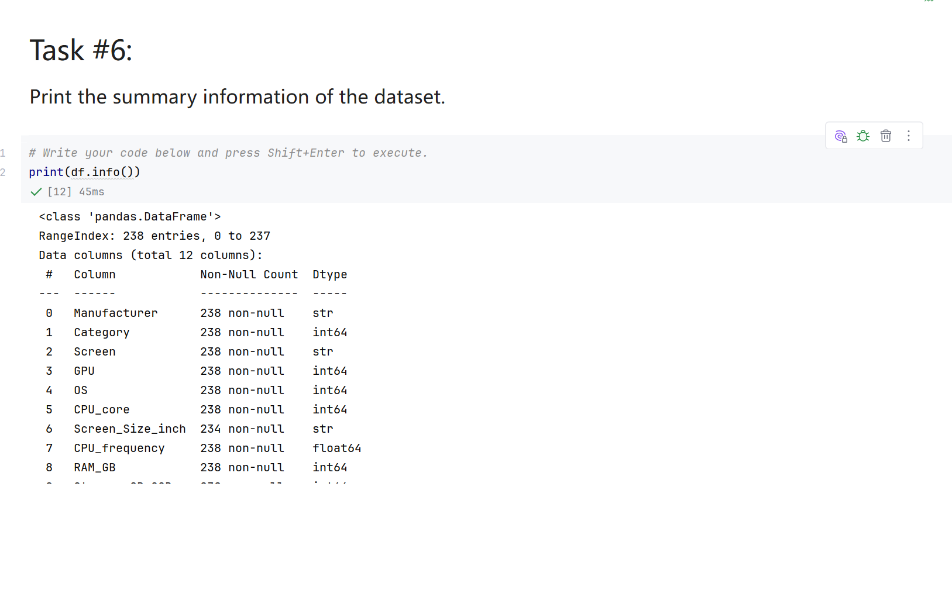
Screenshot file: 08_Task6_print_df.info.png
(image width 16.4 cm, scale to fit)
print(df.info()) reports the index, the number of non null values per column and the memory usage. It shows 234 values for Screen Size inch and 233 for Weight kg, the missing entries created by the previous step.

